**Chapter : 1**

**Car Price Prediction**

**INTRODUCTION**

**1.1 Background of the Study**



The automotive industry is a significant component of the global economy, contributing to manufacturing, trade, and employment. With the advancement of technology and data analytics, predicting car prices has become a critical task for various stakeholders, including manufacturers, dealers, buyers, and financial institutions. Accurate car price prediction can aid in inventory management, pricing strategies, market analysis, and consumer decision-making.

**Importance of Car Price Prediction**

1. **Manufacturers and Dealers:**
   * **Inventory Management:** Helps in managing stock levels by understanding demand patterns and pricing trends.
   * **Pricing Strategies:** Assists in setting competitive prices to maximize profit and market share.
   * **Market Analysis:** Provides insights into market dynamics, helping in the strategic planning and forecasting.
2. **Buyers:**
   * **Informed Decisions:** Enables buyers to make informed decisions by understanding the fair market value of cars.
   * **Negotiation Power:** Enhances buyers' negotiation power by providing a basis for price discussions.
3. **Financial Institutions:**
   * **Loan and Insurance:** Aids in determining the loan amount and insurance premiums based on accurate car valuations.
   * **Risk Management:** Helps in assessing the residual value of cars for lease and finance products.

**Methodologies for Car Price Prediction**

1. **Statistical Methods:**
   * **Regression Analysis:** Linear and non-linear regression models to identify relationships between car attributes and prices.
   * **Time Series Analysis:** Analyzing historical price trends to predict future prices.
2. **Machine Learning Techniques:**
   * **Supervised Learning:** Algorithms such as decision trees, random forests, and support vector machines trained on labeled data.
3. **Data Sources:**
   * **Historical Sales Data:** Records of previous car sales including prices and attributes.
   * **Market Listings:** Current car listings from online marketplaces and dealer inventories.
   * **Consumer Reviews:** Feedback and ratings from car owners influencing perceived value.

**Steps in Car Price Prediction**

**Challenges in Car Price Prediction**

1. **Data Quality and Availability:**
   * Handling missing or inconsistent data.
2. **Model Complexity:**
   * Balancing model complexity with interpretability and computational efficiency.
   * Avoiding overfitting to ensure robust predictions on unseen data.
3. **Market Volatility:**
   * Adapting to rapid changes in market conditions and external factors.
   * Incorporating real-time data for dynamic pricing models.

**1.2 Statement of the Problem**

Accurately predicting the price of cars is a complex and challenging task that holds significant importance for various stakeholders within the automotive industry, including manufacturers, dealers, buyers, and financial institutions. Despite the availability of historical sales data and advanced analytical tools, there are several unresolved issues and challenges in predicting car prices with high precision.

**Problem Statement**

The primary problem addressed in this study is the development of an accurate and reliable model for predicting car prices based on a wide range of influencing factors. This involves identifying and analyzing the key determinants of car prices, processing and cleaning large datasets, and applying appropriate statistical and machine learning methodologies to predict car prices effectively.

Specifically, the following issues need to be addressed:

1. **Data Quality and Availability:**
   * Ensuring the availability of comprehensive and high-quality data that includes relevant features such as model, year, kilometers driven, fuel type.
   * Dealing with missing, inconsistent, or outdated data that can adversely affect the accuracy of the predictions.
2. **Feature Selection and Engineering:**
   * Identifying the most significant features that impact car prices from a potentially vast array of variables.
3. **Model Selection and Optimization:**
   * Choosing the appropriate statistical and machine learning models that can handle the complexity and variability of the data.
   * Optimizing the selected models to improve prediction accuracy while preventing overfitting.
4. **Handling Market Volatility:**
   * Developing models that can adapt to rapidly changing market conditions, including fluctuations in supply and demand, economic factors, and external influences such as regulatory changes and technological advancements.
5. **Interpretability and Transparency:**
   * Ensuring that the predictive models are interpretable and transparent, allowing stakeholders to understand the factors driving the predictions and trust the model outputs.

**1.3 Objectives of the study**

The primary objective of this study is to develop a robust, accurate, and reliable model for predicting car prices. This model aims to assist various stakeholders in the automotive industry, including manufacturers, dealers, buyers, and financial institutions, in making informed decisions. The study focuses on leveraging statistical and machine learning techniques to analyze and predict car prices based on a wide range of influencing factors.

**Specific Objectives**

1. **Data Collection and Preparation:**
   * **Objective:** To gather and preprocess comprehensive datasets from various sources such as historical sales records, online car listings, dealer inventories, and consumer reviews.
   * **Outcome:** A clean and well-structured dataset that is ready for analysis and model training.
2. **Model Development and Comparison:**

**Objective:** To develop and compare Linear Regression model for car price prediction.

* + **Outcome:** Identification of the best-performing model(s) in terms of accuracy, and computational efficiency.

1. **Interpretability and Transparency:**
   * **Objective:** To ensure that the predictive model is interpretable and transparent, enabling stakeholders to understand the factors driving the predictions and trust the model outputs.
   * **Outcome:** An interpretable model that provides actionable insights into the determinants of car prices.
2. **Implementation and Application:**
   * **Objective:** To develop a user-friendly application or interface that allows stakeholders to input relevant car attributes and receive accurate price predictions.
   * **Outcome:** A practical tool that can be used by manufacturers, dealers, buyers, and financial institutions for various purposes such as pricing strategies.

By achieving these objectives, the study aims to provide a valuable tool for predicting car prices, ultimately enhancing the efficiency and effectiveness of decision-making processes in the automotive industry.

**1.4 Scope of the Study**

The scope of this study encompasses the development, validation, and application of a model for predicting car prices. The study focuses on several key areas to ensure comprehensive coverage of the factors influencing car prices and the creation of a reliable prediction tool.

**Data Scope**

* Historical Sales Data: The study will use historical car sales data, including prices and associated attributes, collected from multiple sources such as dealerships, online car marketplaces, and automotive databases.

**Feature Scope**

* Vehicle Attributes: The study will include features such as model, year, kilometer driven,fuel type.

**Methodological Scope**

* Data Processing: Comprehensive data cleaning, preprocessing, and feature engineering to prepare the dataset for model training.
* Model Development: The study will explore various statistical and machine learning models, including linear regression method.

**Temporal Scope**

* Historical Data Range: The study will consider historical data from the past 5-10 years to capture long-term trends and patterns.

**Application Scope**

* Manufacturers and Dealers: The model will assist in pricing strategies, inventory management, and market analysis.
* Buyers: Providing a tool for buyers to estimate fair market value, enhancing their decision-making process.

**Exclusions**

* Non-Standard Vehicles: The study will exclude non-standard or highly customized vehicles due to their unique pricing factors that are not representative of the general market.
* Non-Consumer Vehicles: Commercial vehicles, heavy-duty trucks, and other non-consumer vehicles will be outside the scope of this study.
* Global Market Analysis: While the methodology can be adapted, the study will not focus on a global market analysis due to the complexity and variability of different regional markets.

By defining this scope, the study aims to create a focused and actionable car price prediction model that can be effectively used by various stakeholders in the automotive industry.

**1.5 Significance of the Study**

The develop machine learning models use car prices based on input features such as car model,car company,kilometer driven,fuel type.The project showcased the significance of data preprocessing and analysis in optimizing model performance.

The significance of the study on car price prediction lies in its potential to bring substantial benefits to various stakeholders in the automative industry, including manufacturers, dealers, buyers, and financial institutions. The study aims to enhance decision-making processes, optimize business operations, and provide valuable insights into market dynamics. In economic forecast,it helps in understanding the accurate second handed car model price based on some attributes.

**ALGORITHM**

**Step 1:**

import pandas as pd

car=pd.read_csv("quicker_car.csv")

car.head()

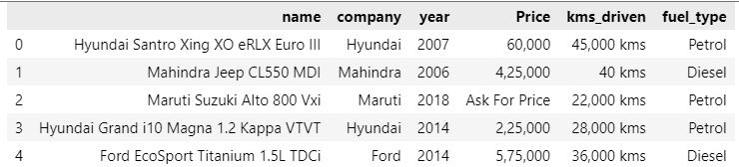

**Step 2:**

car.shape

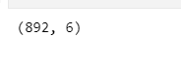

**Step 3:**

car.info()

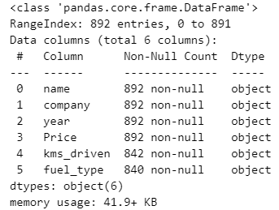

**Step 4:**

car['year'].unique()

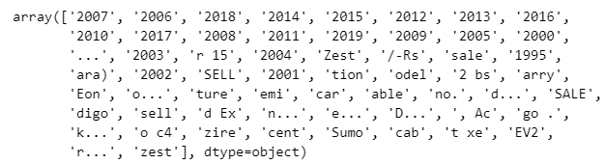

**Step 5:**

car['Price'].unique()

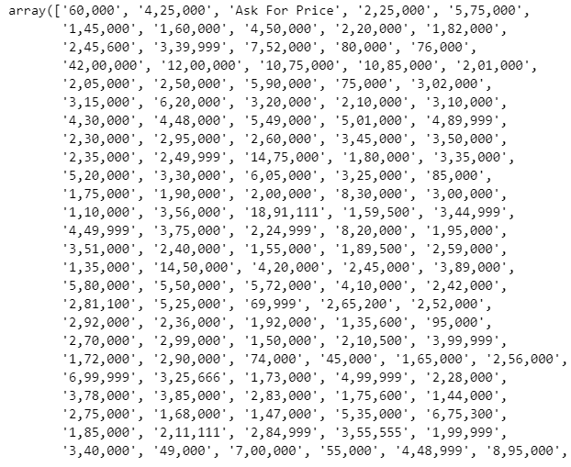

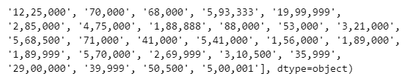

**Step 6:**

car['fuel_type'].unique()



**Step 7:**

backup=car.copy()

backup.info()

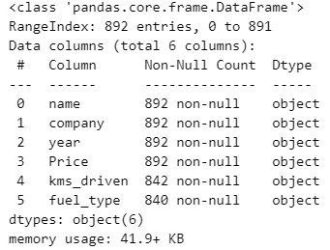

**Step 8:**

car=car[car["year"].str.isnumeric()]

car['year'] = car['year'].astype(int)

car.info()

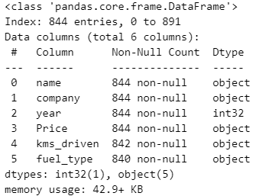

**Step 9:**

car=car[car['Price']!='Ask For Price']

car['Price']=car['Price'].str.replace(',','').astype('int')

car['Price'].unique()

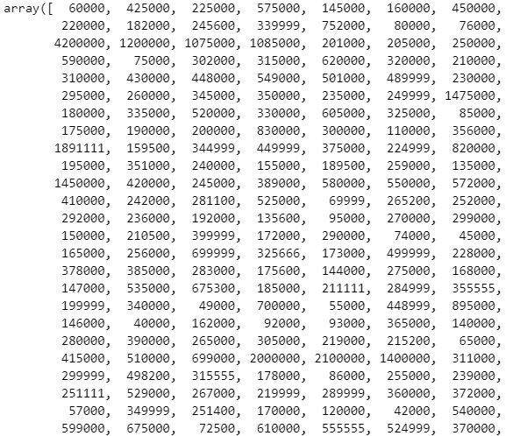

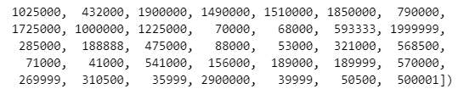

**Step 10:**

car.info()

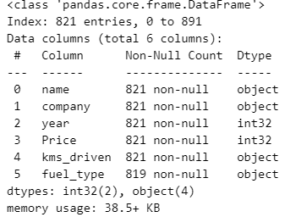

**Step 10:**

car['kms_driven']=car['kms_driven'].str.split(' ').str.get(0).str.replace(',','')

car=car[car['kms_driven'].str.isnumeric()]

car['kms_driven']=car['kms_driven'].astype('int')

car['kms_driven'].unique()

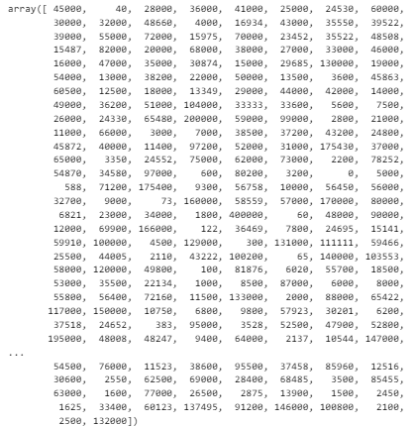

**Step 11:**

car.info()

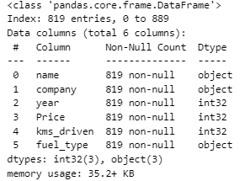

**Step 11:**

car=car[~car['fuel_type'].isna()]

car.info()

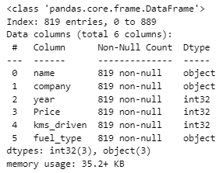

**Step 12:**

car['name']=car['name'].str.split(' ').str.slice(0,3).str.join(' ')

car.info()

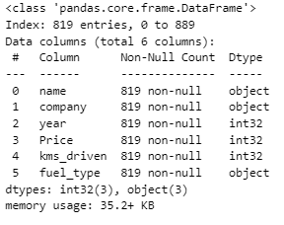

**Step 13:**

car

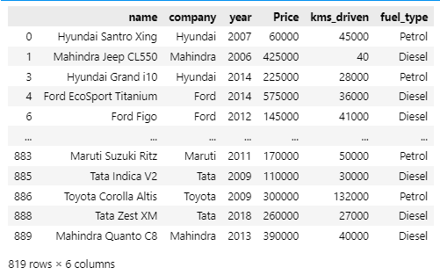

**Step 14:**

car.reset_index(drop=True)

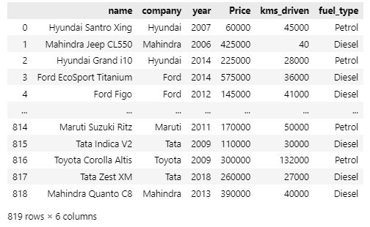

**Step 15:**

car=car.reset_index(drop=True)

car.info()

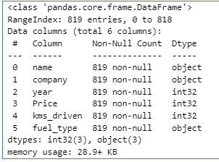

**Chapter : 2**

**Whatsapp chat analysis**

**INTRODUCTION**

* 1. **Background of the Study**



WhatsApp, a widely-used instant messaging platform, generates vast amounts of textual data. Analyzing this data can provide insights into communication patterns, social dynamics, and behavioral trends. WhatsApp chat analysis involves examining chat logs to extract meaningful information using various data analysis techniques.

**Purpose of Whatsapp Chat Analysis**

* **Personal Use:** Understanding personal communication habits, identifying most frequent contacts, most busy time of a day , most busy day etc.
* **Research:** Studying communication patterns, language use, and social interactions for sociological or linguistic research.
* **Business:** Gaining insights into customer service interactions, improving customer support, and analyzing market trends.

**Methodologies for Whatsapp Chat Analysis**

1. **Regular Expression :** Regular Expression helps to identify the patterns inside the exported whatsapp chat .
2. **Natural Language Processing (NLP):** Techniques such as tokenization, stop word removal to process the text data.
3. **Frequency Analysis:** Counting word frequency, message frequency, and identifying the most active times of communication , identify most busy day etc .
4. **Visualization:** Using libraries like Matplotlib , Wordcloud , Seaborn etc to create visual representations of the data.

**Steps in WhatsApp Chat Analysis**

1. **Data Preprocessing:**
   * Converting the text into a suitable format for analysis.
2. **Exploratory Data Analysis (EDA):**
   * Generating basic statistics like the number of messages, words, participants , activity time and busiest day .
   * Visualizing the frequency of messages over time.
3. **Visualization:**
   * Creating graphs to analysing monthly timeline .
   * Creating word clouds to visualize the most frequently used words.
   * Plotting message frequency over time to identify trends and patterns.
   * Using of Heat map to visualize the weekly activity easily.

**2.2 Statement of the Problem**

The rapid growth of digital communication through platforms like WhatsApp has resulted in vast amounts of unstructured textual data. While this data holds potential insights into communication patterns, social behaviors, extracting and analyzing this information is challenging. Current methods lack the efficiency and accuracy needed to process and interpret large volumes of chat data effectively. Consequently, there is a need for a comprehensive WhatsApp Chat Analyzer that can systematically analyze chat logs to provide meaningful insights.

1. **Data Overload:**
   * Users generate extensive chat histories, making it difficult to manually analyze and extract relevant information.
2. **Communication Patterns:**
   * Understanding communication patterns, such as frequency of messages, active times, and social network dynamics, requires sophisticated analytical techniques.
3. **Privacy and Security:**
   * Analyzing personal chat data raises concerns about privacy and data security, necessitating robust measures to protect user information.
4. **Accessibility and Usability:**
   * Existing tools may not be user-friendly or accessible to individuals without technical expertise, limiting their practical application.

**2.3 Objective of the Study**

The objective of a WhatsApp chat analysis study typically involves extracting, analyzing, and interpreting communication patterns, behaviors from chat data. Here are some possible objectives you might consider:

1. **Understanding Communication Patterns**: Identify how often participants communicate, the time of day when conversations are most active, and the frequency of responses.
2. **Word Analysis**: Identify the most common words discussed and how frequently they appear in conversations. This could involve clustering messages into different themes or topics.
3. **User Engagement Analysis**: Measure the level of engagement and participation of each user in the chat to identify active time between contributors and passive participants.

**2.4 Scope of the Study**

The scope of a WhatsApp chat analysis study defines the boundaries and limitations of the research. It outlines what the study will cover and what it will not, providing a clear framework for the analysis. Here’s a possible scope for your study:

**1. Data Collection**

* **Source**: The study will analyze WhatsApp exported chat data collected from specific individuals or groups .
* **Timeframe**: The exported chat data must be in 24 hr and dd/mm/yyyy format .
* **Type of Data**: The study will focus on text messages .

**2. Participants**

* **Privacy and Ethics**: All data will be anonymized to protect the privacy of participants, and ethical guidelines will be followed to ensure that consent has been obtained for the analysis.

**3. Analytical Focus**

* **Communication Patterns**: The study will examine the frequency, timing, and exchanged between participants.
* **Keyword/Topic Analysis**: Words, or phrases commonly discussed in the chats will be identified and analyzed.

**5. Limitations**

* **Generalizability**: Findings from the study may be specific to the particular group(s) or individual(s) analyzed and may not be generalizable to broader populations.
* **Language**: The study will focus on the primary language used in the chats and may not account for multilingual nuances or slang.

**6. Expected Outcomes**

* **Applications**: The results can be used to improve communication strategies, resolve conflicts, or enhance understanding of group dynamics.

**7. Exclusions**

* **Real-Time Analysis**: The scope does not include real-time monitoring of chat data but is restricted to historical analysis.

**2.5 Significance of the study**

Analyzing WhatsApp chats can provide valuable insights for various fields, depending on the context of the study. Analyzing chat data can reveal how people communicate, including the frequency, The most busy user of the group chat , timing of conversations , Most busy days , most busy months etc. This can be important for understanding group dynamics, or even organizational communication.

The significance of **Whatsapp Chat Analysis** lies in its potential to show the proper analytics of the provided exported chat to the end user or the customer. It uses bar charts, pie charts, histogram, heat map , word cloud to maintain the easily understandable interface .

**Chapter : 3**

**Stock Price Prediction**

**INTRODUCTION**

* 1. **Background of the Study**

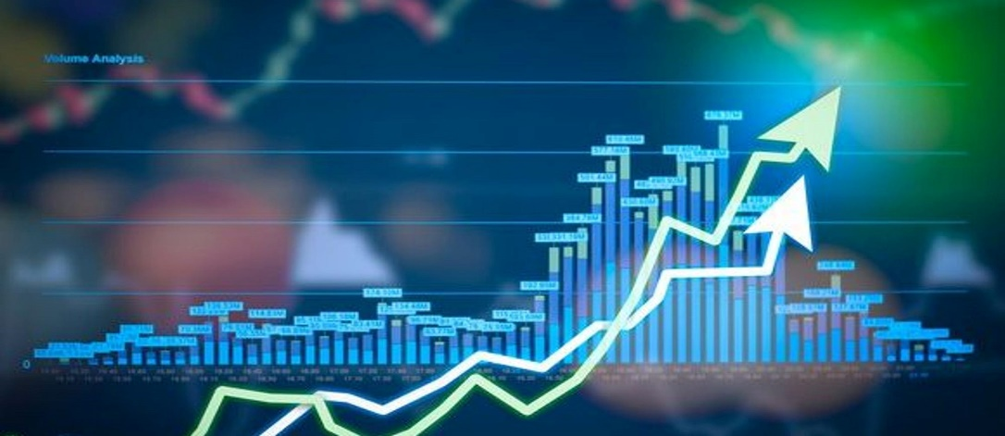

Stock price prediction is a significant area of research within the fields of finance, economics, and data science. The study of stock price prediction revolves around the development and application of various models and algorithms to forecast the future prices of stocks, based on historical data, market trends, and other relevant factors. The motivation for this research stems from the potential financial benefits and the importance of stock market predictions for investors, financial institutions, and policymakers.

**Purpose of Whatsapp Chat Analysis**

**Methodologies for Whatsapp Chat Analysis**

**Steps in WhatsApp Chat Analysis**

1. **Data Preprocessing:**
   * Converting the text into a suitable format for analysis.
2. **Exploratory Data Analysis (EDA):**
   * Generating basic statistics like the number of messages, words, participants , activity time and busiest day .
   * Visualizing the frequency of messages over time.
3. **Visualization:**
   * Creating graphs to analysing monthly timeline .
   * Creating word clouds to visualize the most frequently used words.
   * Plotting message frequency over time to identify trends and patterns.
   * Using of Heat map to visualize the weekly activity easily.

**2.2 Statement of the Problem**

The rapid growth of digital communication through platforms like WhatsApp has resulted in vast amounts of unstructured textual data. While this data holds potential insights into communication patterns, social behaviors, extracting and analyzing this information is challenging. Current methods lack the efficiency and accuracy needed to process and interpret large volumes of chat data effectively. Consequently, there is a need for a comprehensive WhatsApp Chat Analyzer that can systematically analyze chat logs to provide meaningful insights.

1. **Data Overload:**
   * Users generate extensive chat histories, making it difficult to manually analyze and extract relevant information.
2. **Communication Patterns:**
   * Understanding communication patterns, such as frequency of messages, active times, and social network dynamics, requires sophisticated analytical techniques.
3. **Privacy and Security:**
   * Analyzing personal chat data raises concerns about privacy and data security, necessitating robust measures to protect user information.
4. **Accessibility and Usability:**
   * Existing tools may not be user-friendly or accessible to individuals without technical expertise, limiting their practical application.

**2.3 Objective of the Study**

The objective of a WhatsApp chat analysis study typically involves extracting, analyzing, and interpreting communication patterns, behaviors from chat data. Here are some possible objectives you might consider:

1. **Understanding Communication Patterns**: Identify how often participants communicate, the time of day when conversations are most active, and the frequency of responses.
2. **Word Analysis**: Identify the most common words discussed and how frequently they appear in conversations. This could involve clustering messages into different themes or topics.
3. **User Engagement Analysis**: Measure the level of engagement and participation of each user in the chat to identify active time between contributors and passive participants.

**2.4 Scope of the Study**

The scope of a WhatsApp chat analysis study defines the boundaries and limitations of the research. It outlines what the study will cover and what it will not, providing a clear framework for the analysis. Here’s a possible scope for your study:

**1. Data Collection**

* **Source**: The study will analyze WhatsApp exported chat data collected from specific individuals or groups .
* **Timeframe**: The exported chat data must be in 24 hr and dd/mm/yyyy format .
* **Type of Data**: The study will focus on text messages .

**2. Participants**

* **Privacy and Ethics**: All data will be anonymized to protect the privacy of participants, and ethical guidelines will be followed to ensure that consent has been obtained for the analysis.

**3. Analytical Focus**

* **Communication Patterns**: The study will examine the frequency, timing, and exchanged between participants.
* **Keyword/Topic Analysis**: Words, or phrases commonly discussed in the chats will be identified and analyzed.

**5. Limitations**

* **Generalizability**: Findings from the study may be specific to the particular group(s) or individual(s) analyzed and may not be generalizable to broader populations.
* **Language**: The study will focus on the primary language used in the chats and may not account for multilingual nuances or slang.

**6. Expected Outcomes**

* **Applications**: The results can be used to improve communication strategies, resolve conflicts, or enhance understanding of group dynamics.

**7. Exclusions**

* **Real-Time Analysis**: The scope does not include real-time monitoring of chat data but is restricted to historical analysis.

**2.5 Significance of the study**

Analyzing WhatsApp chats can provide valuable insights for various fields, depending on the context of the study. Analyzing chat data can reveal how people communicate, including the frequency, The most busy user of the group chat , timing of conversations , Most busy days , most busy months etc. This can be important for understanding group dynamics, or even organizational communication.

The significance of **Whatsapp Chat Analysis** lies in its potential to show the proper analytics of the provided exported chat to the end user or the customer. It uses bar charts, pie charts, histogram, heat map , word cloud to maintain the easily understandable interface .